

**IT3021**

**Data Warehousing and Business**

**Intelligence**

**3rdYear 1stSemester**

**Assignment 2**

**Student NO: IT19960814**

**Name: ALWIS. P. L. A.I**

Submitted to:

Sri Lanka Institute of Information Technology

## Content of the Dataset

This dataset mainly focused on fulfillment centers in these cities for dispatching meal orders to their customers. The replenishment of majority of raw materials is done on weekly basis and since the raw material is perishable, the procurement planning is of utmost importance. Secondly, staffing of the centers is also one area wherein accurate demand forecasts are helpful. Given the following information, the task is to predict the demand for the next weeks for the center-meal combinations in the test set.

## R Diagram of the Dataset

**Step 1: Data source for the assignment 2**

* IT19960814_DW that I have implemented and loaded with data in Assignment 1 as the data source for the assignment 2.

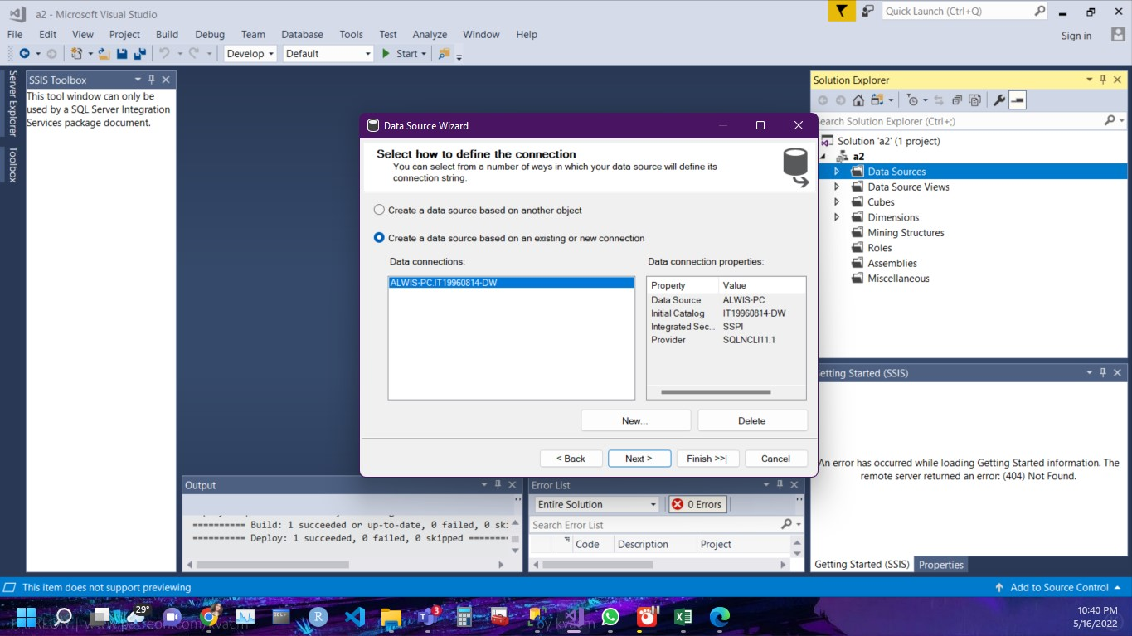

Create Data Source :

A) Right click on the Data Sources under created project and click on New Data Source

B) Click correct data base schema (Data warehouse) and next

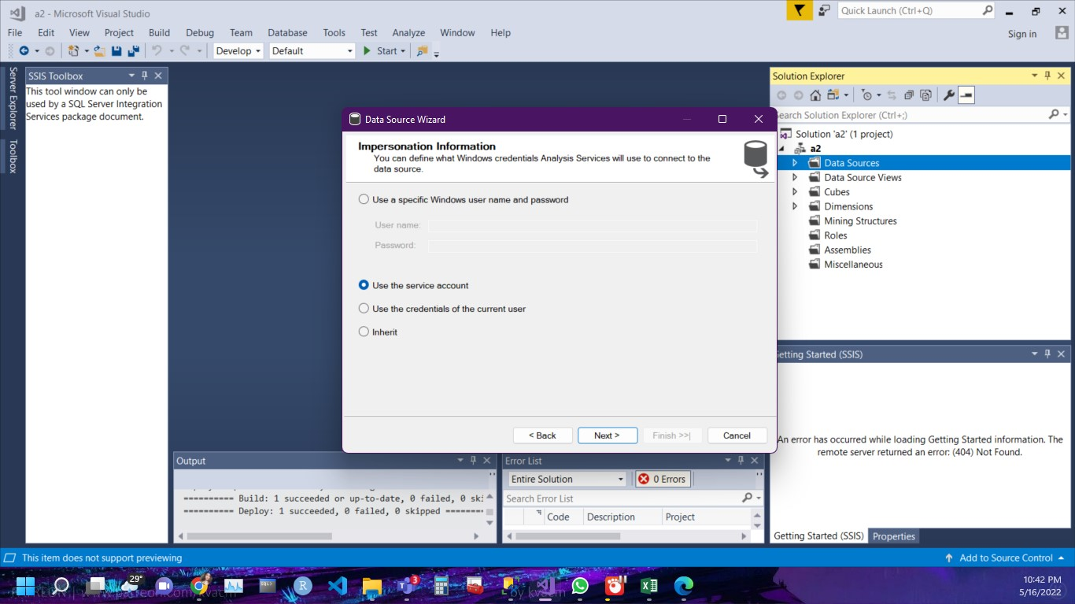

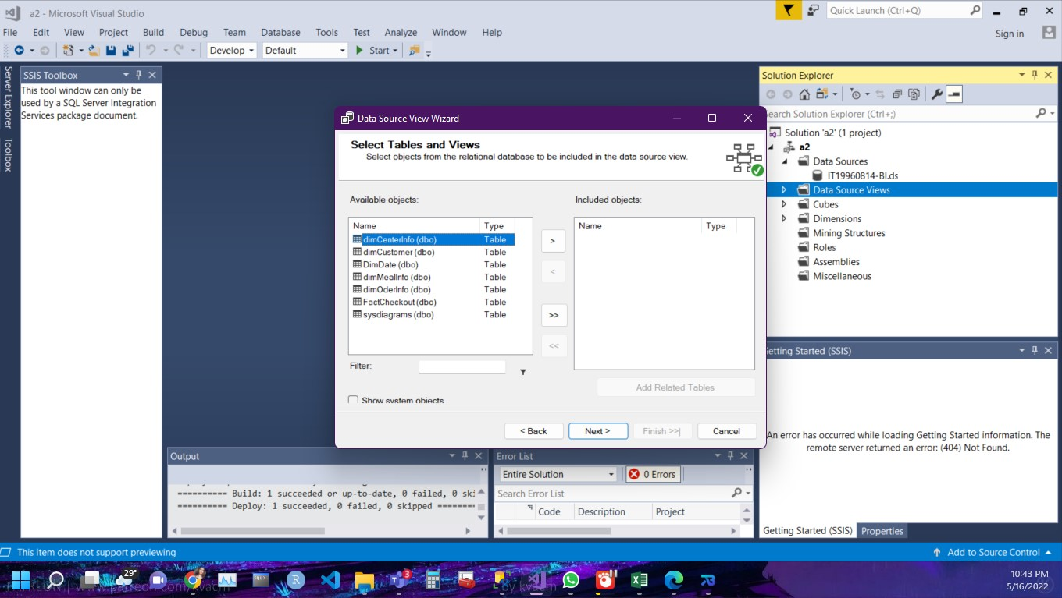

Create Data Source Views :

A) Right click on the New Data Source View under SSAS Project

B) Select All the Available dimension tables into Included Objects and click Finish

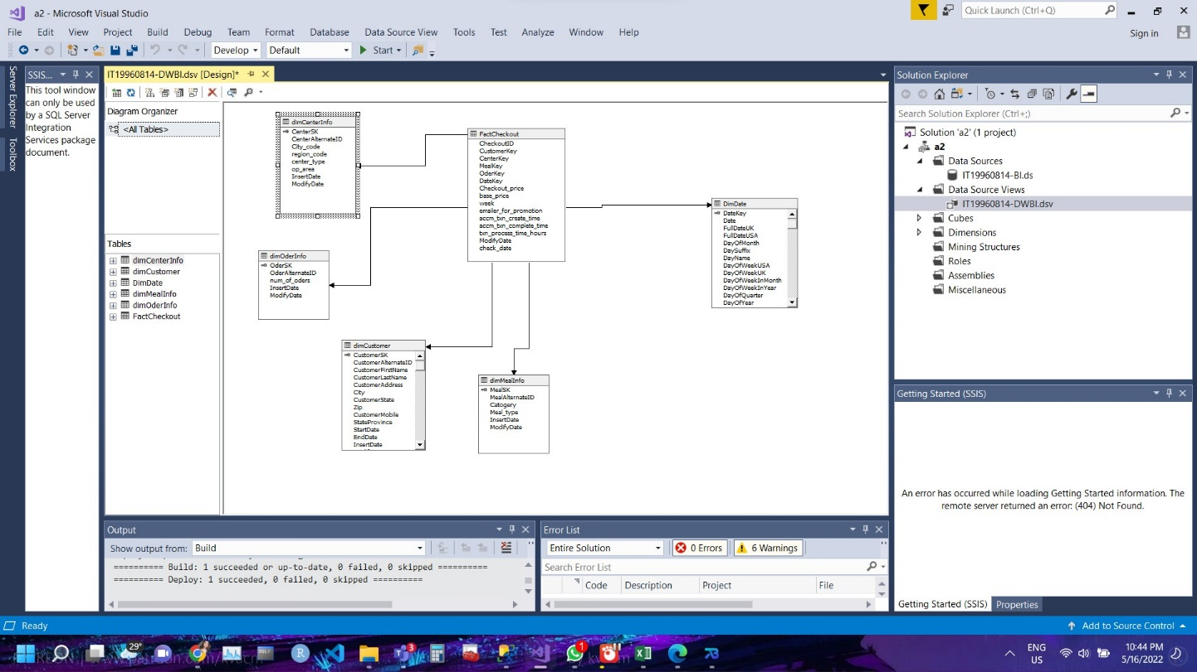

**Step 2: SSAS Cube implementation**

A) Under SSAS project right click on the cube and New Cube

B) Use Existing table -> Next

C) Select the All Fact tables and Next

D) Select all the transaction attributes and Next.

E) Select all the dimension tables and Next.

F)Finish

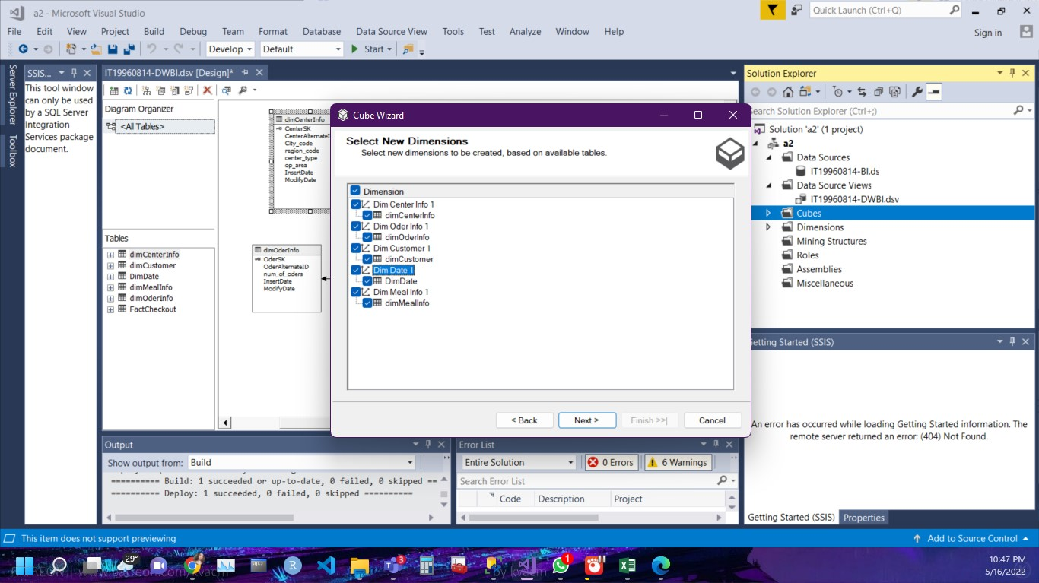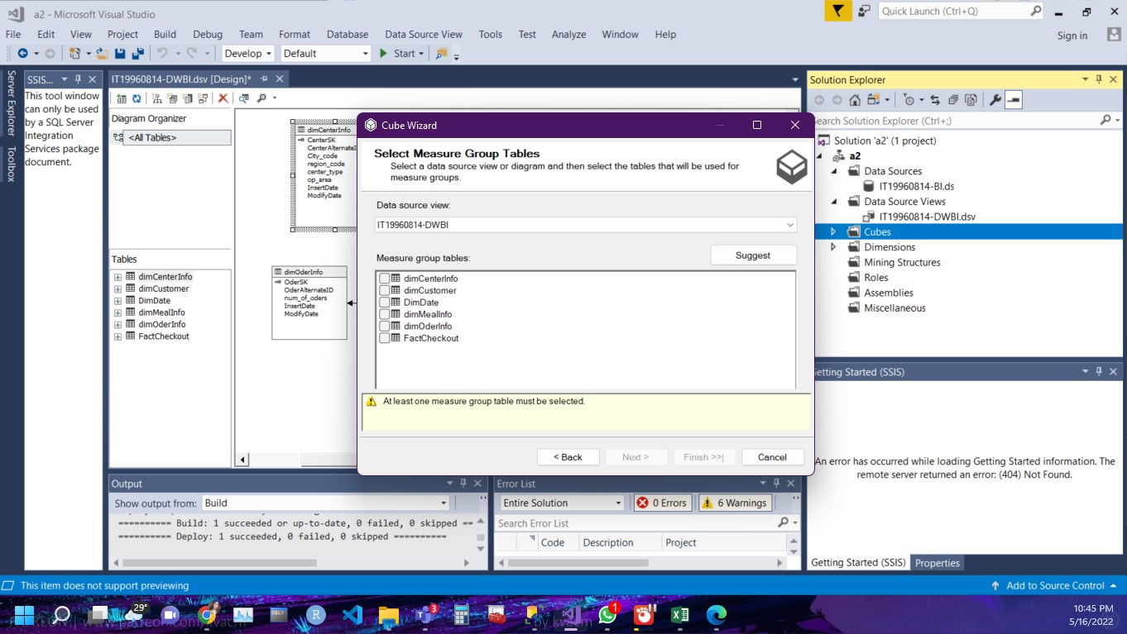

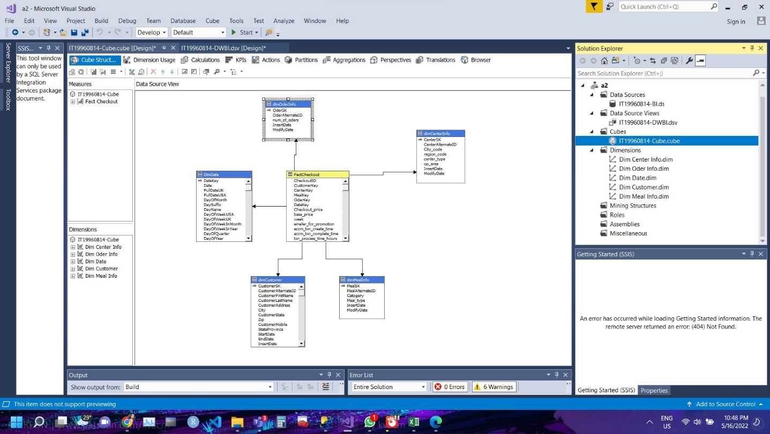

Create Hierarchies

Hierarchies are useful in visual reporting tools to show the parent/child relationship between attributes.

Created 2 hierarchies shown below

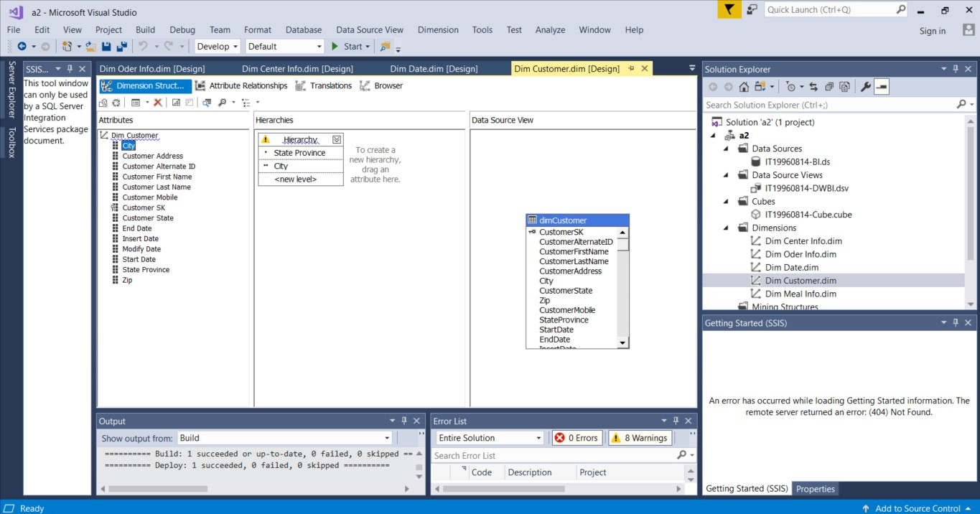

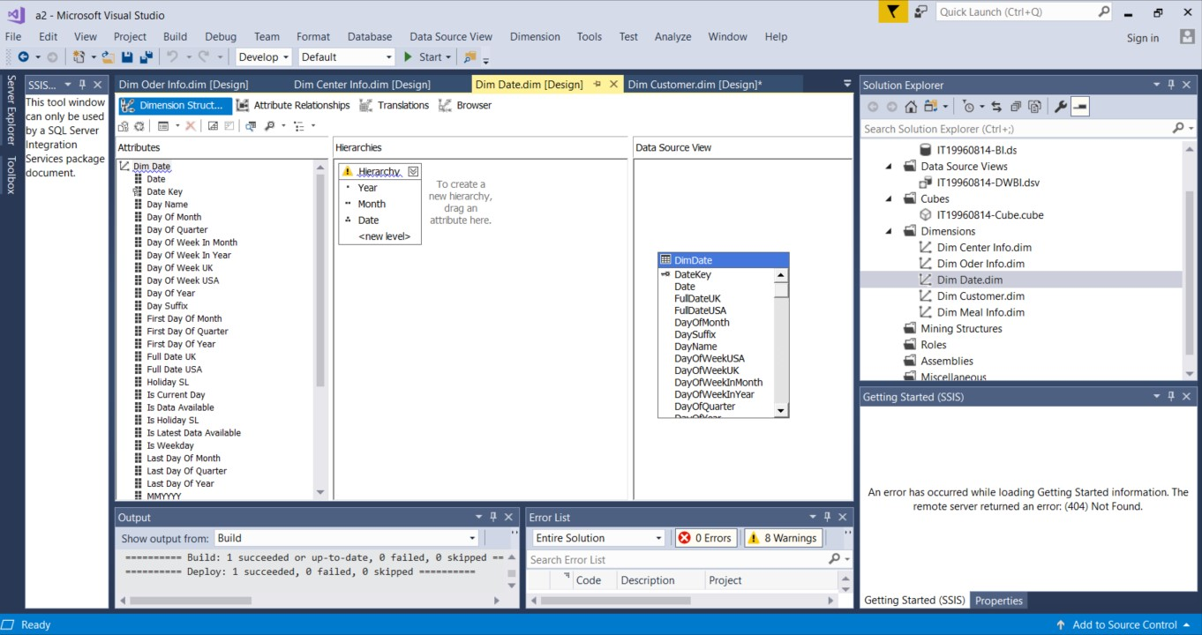

Creating KPI

KPI 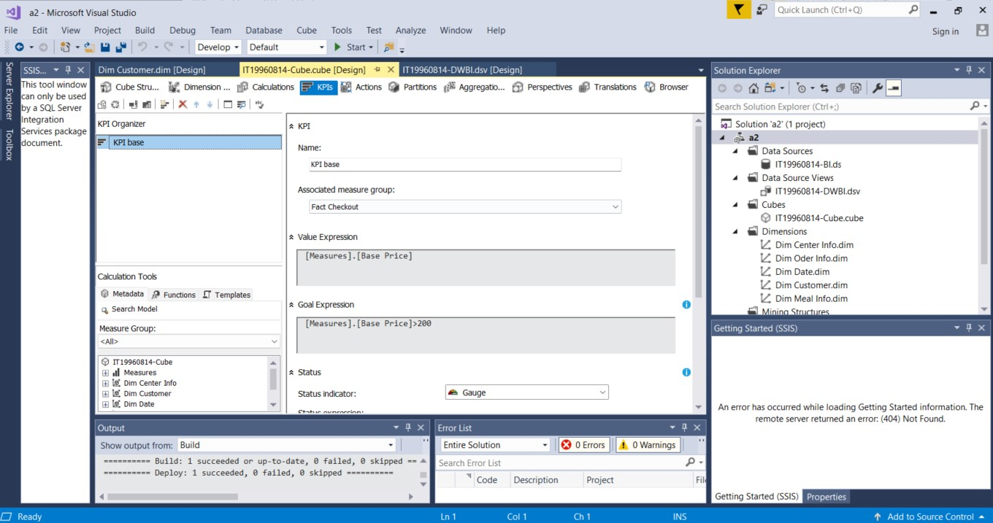for Base price

Finally, I have Deployed the project, I got the deployment is successful message as shown below

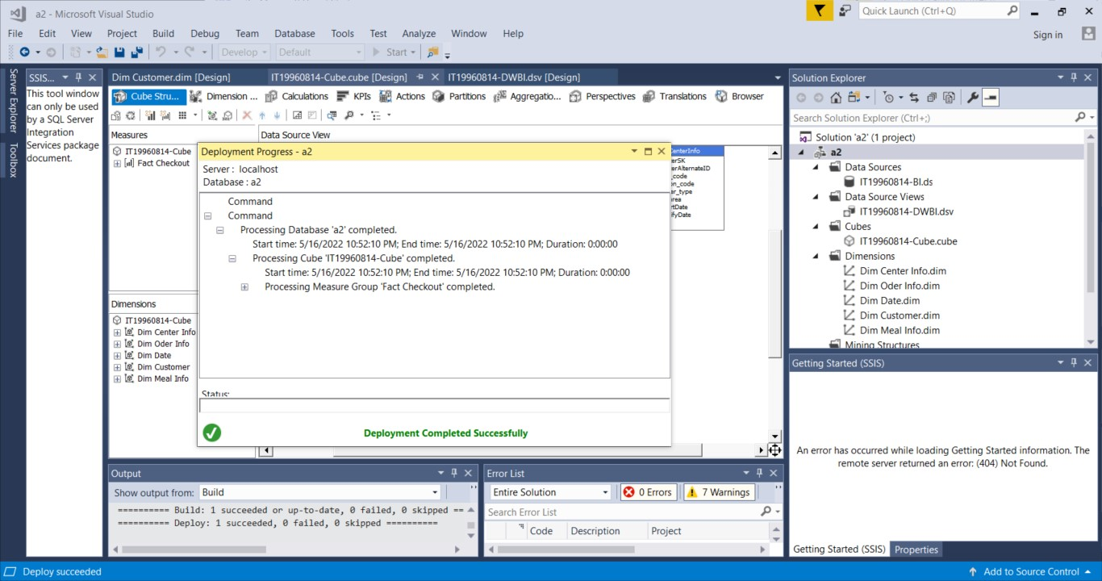

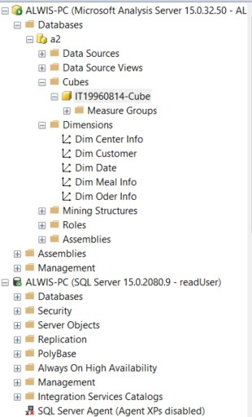data cube

**Step 3: Demonstration of OLAP operations**

Connect an Excel workbook to the Cube. You may use connecting Excel workbook using features available in Data tab or POWERPIVOT mode

A) Data tab and getData-> From Database ->From Analysis Services

B) Set the credentials for database and select SSAS cube and finish

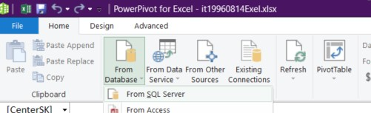

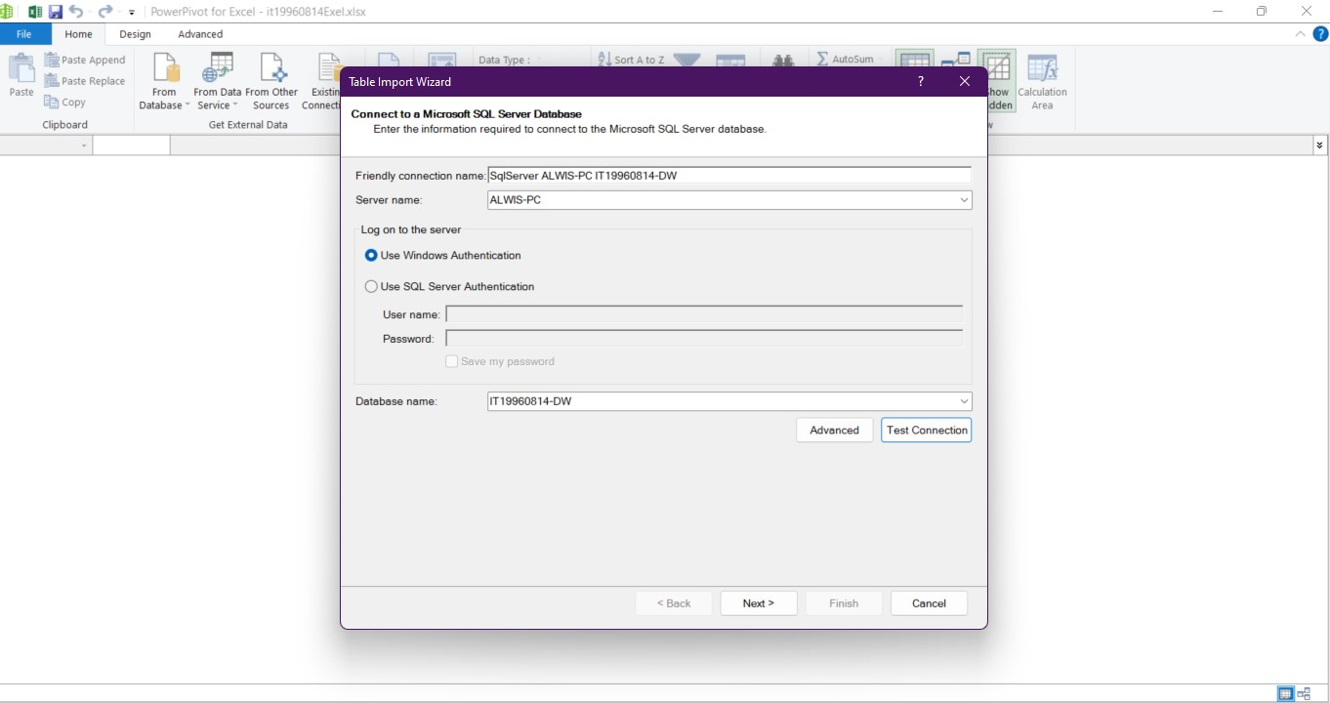

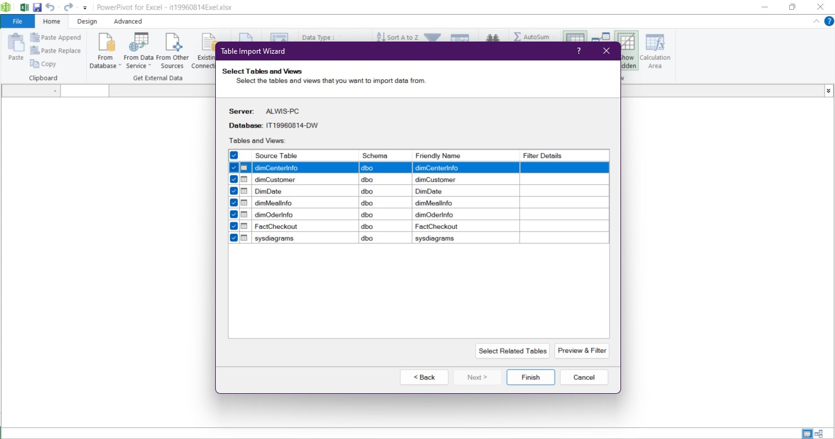

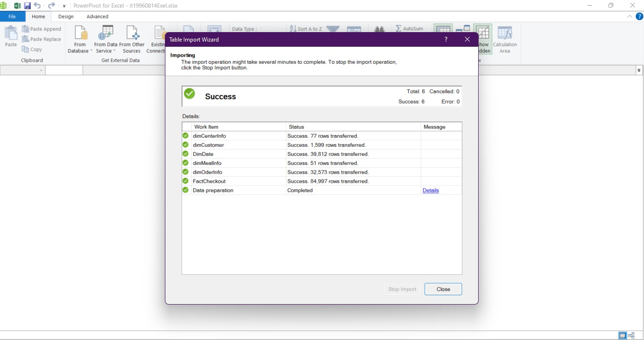

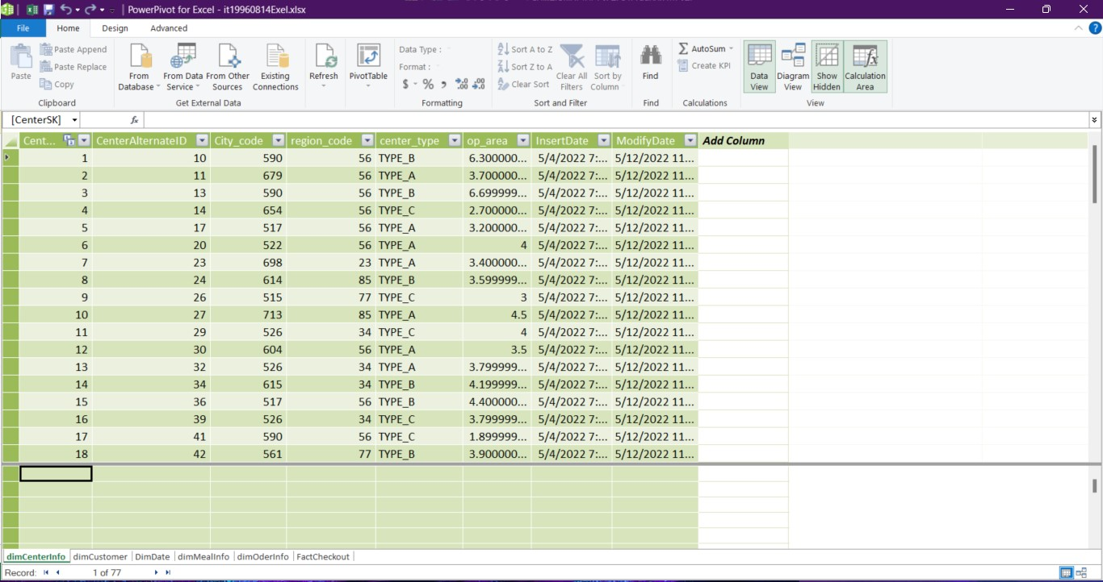

Extract using cube

**Excel report**

***Pivot***

In the below pivot table, I have statically summarized the data. This summary includes base price ,check out price, category, month year, which the pivot table groups together in a descriptive manner in Category. And using this pivot table we can visualize our data by giving them a different perspective and view. We can rotate the axis of the dimension and see different pattern of the same data.

***Slice***

Rectangular subset of a cube, by choosing a single value for one of its dimensions. So here I have used a slicer to filter data in table and graph by State wise.

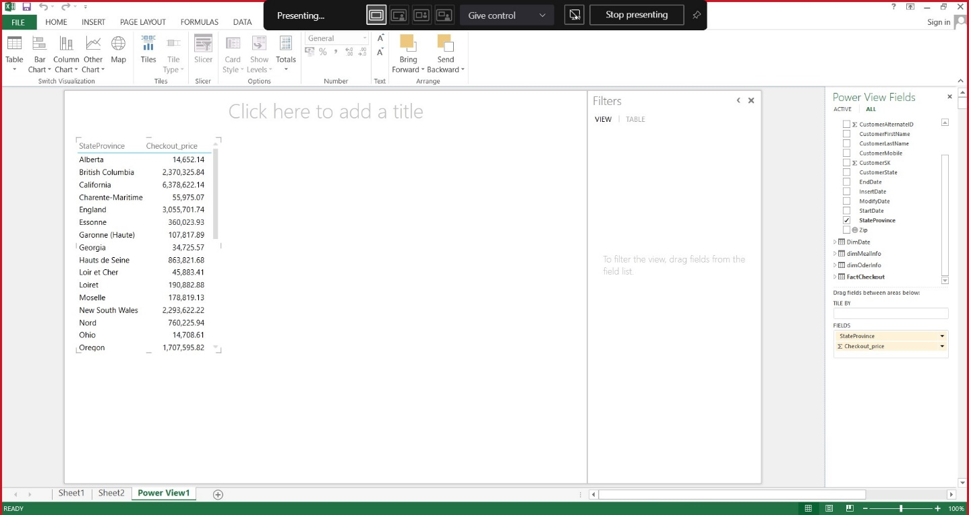

***Dice***

Selects two or more dimensions from a given cube and provides new sub-cube by selecting specific values on those selected dimensions. This report shows states specific values on those selected meal type.

As an instance in below figure, pie chart’s highlighted area emphasizes all values of 4 of base prices different types belongs to state of California.

As an instance in below figure, pie chart’s highlighted area emphasizes all values of 4 of base prices different types belongs to state of Oregon.

***Roll-up and drill-down***

***Roll-Up***

Climbing up a hierarchy of the dimension to aggregate data means the roll up OLAP operation in cubes

***Drill Down***

Stepping down a hierarchy of the dimension allowing navigation through details means the drill down OLAP operation in cube

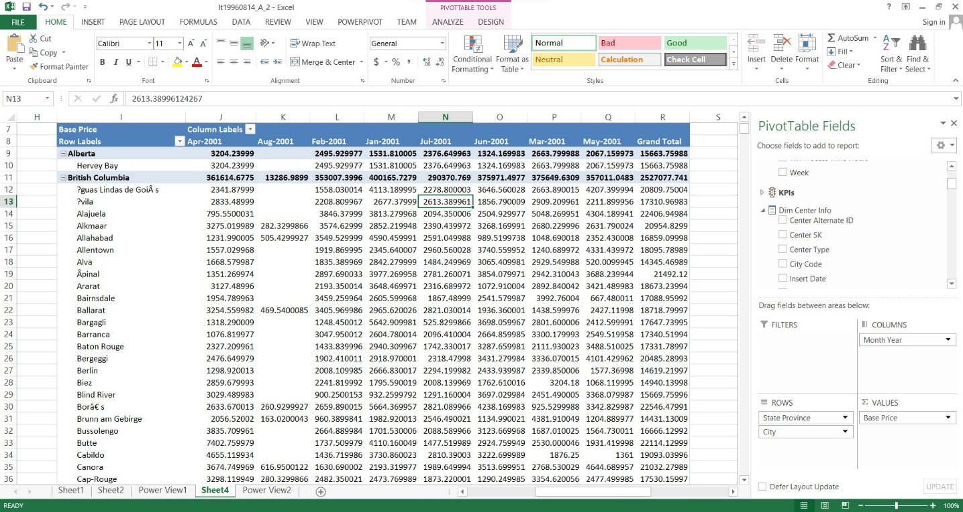

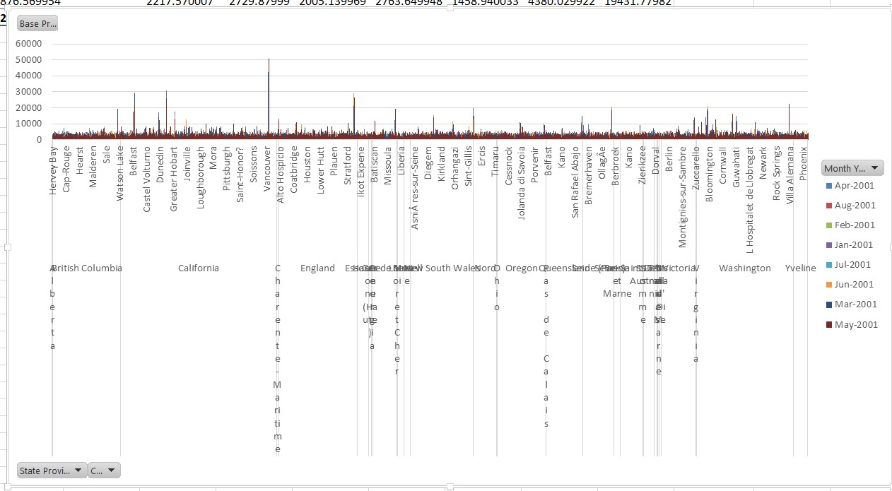

**Step 4: SSRS Reports**

**Report 1: Report with a matrix**

A) Using Report Builder tool define the data set

(Use a data set embedded in my report -> New -> declare the DW)

B) In Query Designer define the relationship between fact table and other dimensions.

C) Insert -> Matrix -> Matrix wizard and declare the row groups and column groups and measures.

D) Row group : Meal Type, Category

Column group : Month Name

Measures : base price

**Design view**

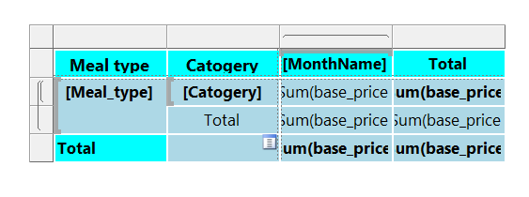

**Preview**

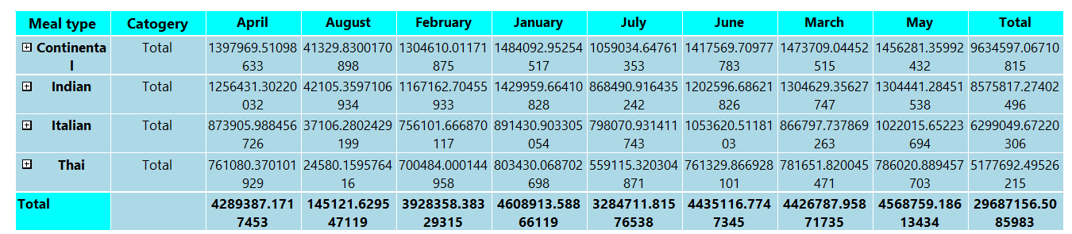

**Final report view**

**Report 2 : Report with more than one parameter**

A) Define the data set (use a data set embedded in my report -> New -> declare the DW) B)

In Query Designer write a query to get all the customer states

C) Declare a parameter and set “available values” to “Get values from a query” and set previous declared data set into it.

D) Define another data set to get customer city according to state(pass the state parameter value into where clause )

E) After declaring a new parameter and set correct data set(2nd data set)

F) After that as the first report follow the steps and set the column values , Row values and measures.

G) Row group : State , City

Column group : Month Name

Measures : Base price

**Design view**

**Preview**

**Final report view**

**Final report view**

**Report 3 : SSRS Drill-down Report**

A) As the earlier define the data set and follow the steps

B) In Column and Row groups set multiple categories into Row group C) Row group : State , CustomerFName , CustomerLName , CustomerAddress

Measures : week , base price

**Design view**

**Preview**

**Final report view**

**Report 4 : SSRS Drill-Through Report**

A) As before creating 2 reports with charts

B) Categories : meal type ,Values : base price

**Preview**

**Final report view**

Categories : category, Values : base price

**Preview**

**Final report view**

**Preview**

Categories : customer state, Values : checkout price

**Final report view**

